Subject: PRF192

Workshop 03

Name: Hoàng Thủy Nguyên

Student ID: DE191056

Write a menu to call three following functions

1. *Function* 1: **Calculate personal income tax**

In Viet Nam, each people has to pay for yearly personal income tax. The general rule is if your

income per month is less than or equal to 9 million VND, you will not pay. Otherwise you will

pay. Specifically, if the income is from 9 000 001 VND to 15 000 000 VND, you must pay 10% of the amount of income that over 9 million VND. If the income is over 15 million VND, you must pay 20% of the amount of income that over 15 million VND. Write a program to calculate the tax that a person must pay, given that the her/his income is inputted from the keyboard.

1. The function is:

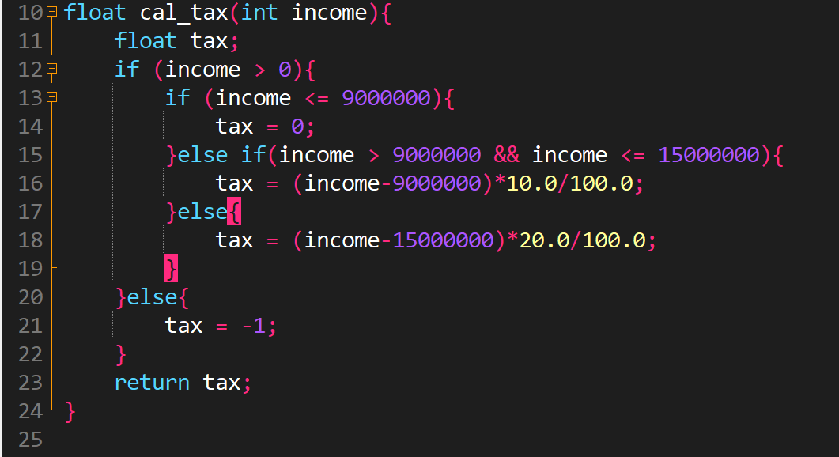

1. Call the function in main function

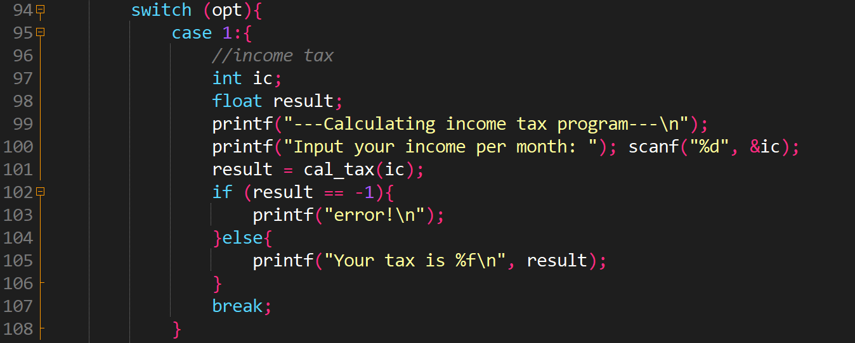

1. Test:

* Case 1:

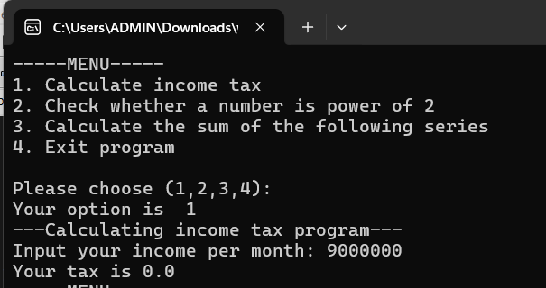

Walkthrough:

Line 92: enter 1 🡪 opt = 1 🡪execute case 1

Line 98: enter 9 000 000 🡪 ic = 9 000 000

Line 10: pass value of ic into function cal_tax 🡪”income” argument = 9 000 000

Line 12: true 🡪 execute condition command

Line 13: true 🡪 execute condition command 🡪 tax = 0

Line 23: function return tax

Line 99: assign result of cal_tax function into “result” variable

Line 102: because tax = 0 🡪 false 🡪 execute else command🡪Line 103: print out on screen “Your tax is 0.0”

Line 144: because opt = 1(different from 4) 🡪true🡪 execute loop command🡪 show menu

* Case 2:

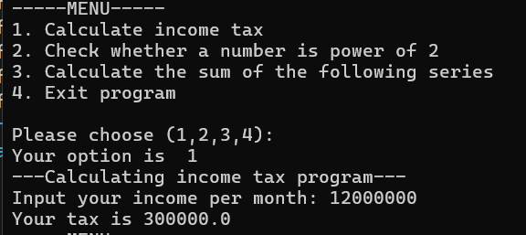

Walkthrough:

Line 92: enter 1 🡪 opt = 1 🡪execute case 1

Line 98: enter 12 000 000 🡪 ic = 12 000 000

Line 10: pass value of ic into function cal_tax 🡪”income” argument = 12 000 000

Line 12: true 🡪 execute condition command

Line 15: true 🡪 execute condition command 🡪 tax = 300 000

Line 23: function return tax

Line 99: assign result of cal_tax function into “result” variable

Line 102: because tax = 300 000 🡪 execute else command🡪Line 103: print out on screen “Your tax is 300 000”

Line 144: because opt = 1(different from 4) 🡪true🡪 execute loop command🡪 show menu

* Case 3:

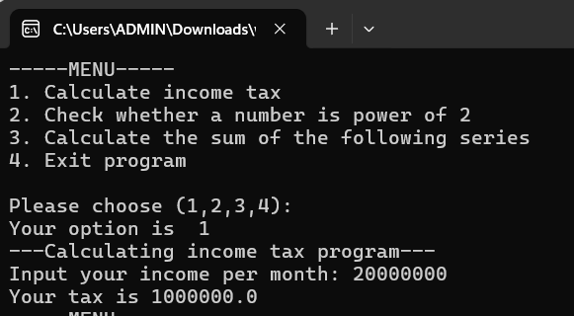

Walkthrough:

Line 92: enter 1 🡪 opt = 1 🡪execute case 1

Line 98: enter 20 000 000 🡪 ic = 20 000 000

Line 10: pass value of ic into function cal_tax 🡪”income” argument = 20 000 000

Line 12: true 🡪 execute condition command

Line 18: true 🡪 execute condition command 🡪 tax = 1 000 000

Line 23: function return tax

Line 99: assign result of cal_tax function into “result” variable

Line 102: because tax = 1 000 000🡪 execute else command🡪Line 103: print out on screen “Your tax is 1 000 000”

Line 144: because opt = 1(different from 4) 🡪true🡪 execute loop command🡪 show menu

* Case 4:

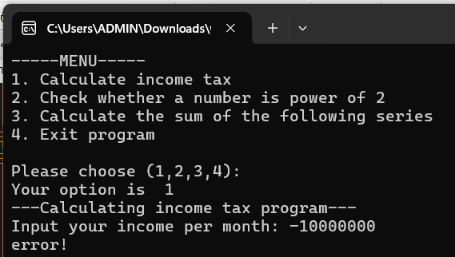

Walkthrough:

Line 92: enter 1 🡪 opt = 1 🡪execute case 1

Line 98: enter -10 000 000 🡪 ic = -10 000 000

Line 10: pass value of ic into function cal_tax 🡪”income” argument = -10 000 000

Line 20: false 🡪 execute else command🡪 tax = -1

Line 23: function return tax

Line 99: assign result of cal_tax function into “result” variable

Line 100: because tax = -1🡪 execute condition command🡪Line 101: print out on screen “error!”

Line 144: because opt = 1(different from 4) 🡪true🡪 execute loop command🡪 show menu

2. *Function* 2 : **Check whether a number is power of 2**

Input a number from the keyboard, then check whether the number is power of 2.

1. The function is:

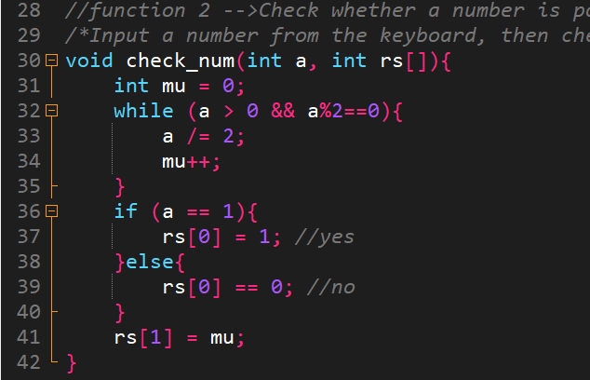

1. Call the function in main function:

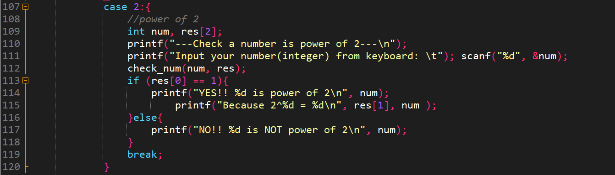

1. Test:

* Case 1:

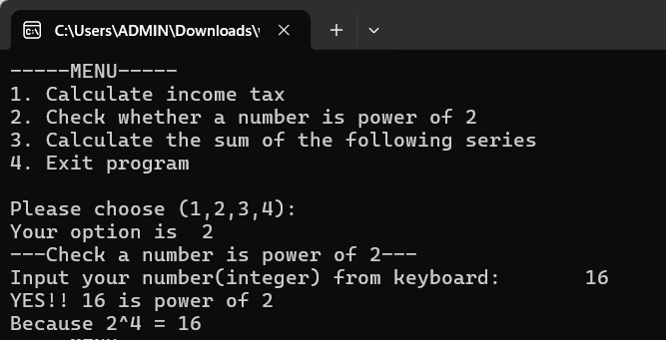

Walkthrough:

Line 92: enter 2 🡪 opt = 2 🡪execute case 2

Line 111: enter 16 🡪 num = 16

Line 112: pass num=16 into check_num function🡪Line 30: a = 16

Line 32: true (because 16>0 and 16 is divisible by 2) 🡪execute loop command

Line 33: a = 8(16/2), mu variable increases by 1

…(looping)

When a = 1 🡪 end loop command

Line 36: true (a=1)🡪execute condition command🡪Line 37: assign 1 to rs[0] variable

Line 38: assign value of “mu” variable to rs[1]

Line 113: pass res[] into check_num function 🡪 res[0] = 1(because rs[0] = 1 of check_num function) 🡪execute condition command🡪print out on screen “YES…”

* Case 2:

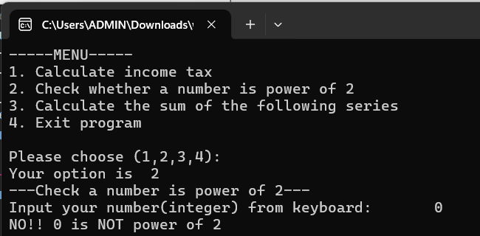

Walkthrough:

Line 92: enter 2 🡪 opt = 2 🡪execute case 2

Line 111: enter 0 🡪 num = 0

Line 112: pass num=0 into check_num function🡪Line 30: a = 0

Line 32: false 🡪 skip loop command

Line 39: false (a=0)🡪execute else command🡪Line 40: assign 0 to rs[0] variable

Line 113: pass res[] into check_num function 🡪 res[0] = 1(because rs[0] = 1 of check_num function) 🡪execute condition command🡪print out on screen “NO…”

3. *Function* 3: **Calculate the sum of the following series.**

Given the sum as follows. Here, x and n are inputted from the keyboard.

1. The function is:

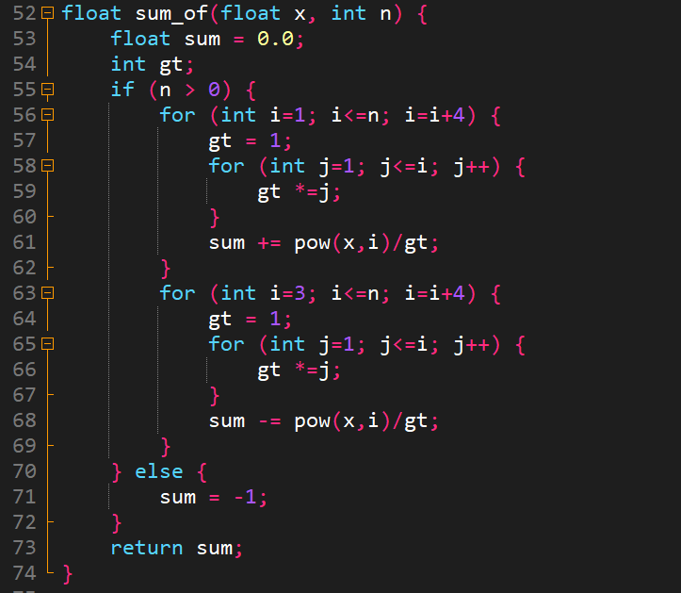

1. Call the function in main function:

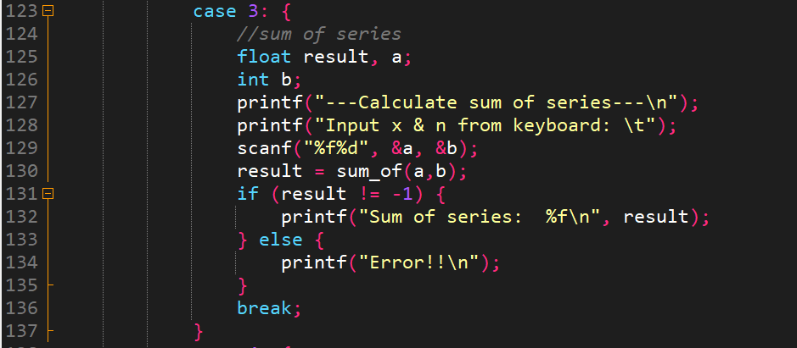

1. Test:

* Case 1:

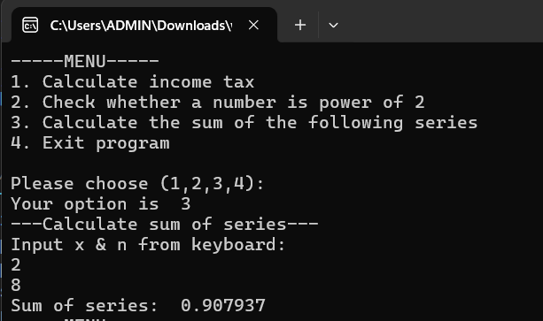

Walkthrough:

Line 92: enter 3🡪opt = 3 🡪 execute case 3:

Line 129: enter 2 8 🡪 a=2, b=8

Line 130: pass a and b into sum_of function 🡪 Line 52: x = 2, n = 8

Line 55: true(8>0🡪execute condition command

Line 57🡪60: calculate factorial

Line 61: sum of positive elements in series

Line 63🡪69: calculate sum of series (including positive and negative elements of series)

Line 73: return sum(result after executing sum_of function)

Line 130: assign result of function to “result” variable

Line 132: print it out on screen ‘Sum of series is: 0.907937’

* Case 2:

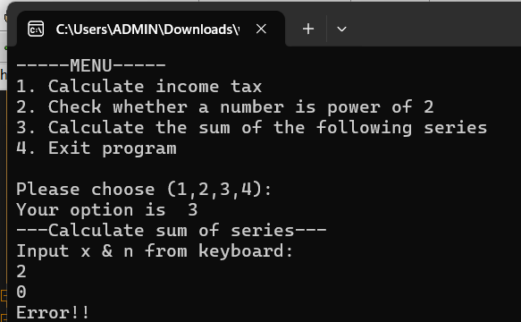

Walkthrough:

Line 92: enter 3🡪opt = 3 🡪 execute case 3:

Line 129: enter 2 🡪 a=2, b=0

Line 130: pass a and b into sum_of function 🡪 Line 52: x = 2, n = 0

Line 70: false(0>0🡪execute else command

Line 71: assign -1 to sum variable

Line 73: return sum(which is result after executing sum_of function)

Line 130: assign result of function to “result” variable

Line 133: false(-1 = -1)🡪execute else command

Line 134: print it out on screen ‘error”